Project Design Phase-II

Data Flow Diagram & User Stories
Project Title | DarshanEase: A Smart Temple Darshan Booking System Using MERN Stack
Team ID | ALITS-CSD-2026-DarshanEase
Team Members | Salapala Tharun Kumar Reddy (Team Leader); A. Goutham; M. Siva Prasad; M. Akhila; K. Hemalatha
College | Anantha Lakshmi Institute of Technology and Sciences (ALITS)
Academic Year | 2026

Data Flow Diagrams
DarshanEase uses a Level 0 context diagram and a Level 1 diagram breaking the system into four core processes: user authentication, temple browsing, darshan booking, and journey planning, each interacting with dedicated MongoDB collections (users, temples, bookings, journeys).
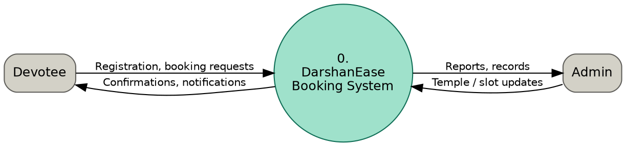
Figure 1: DFD Level 0 — context diagram
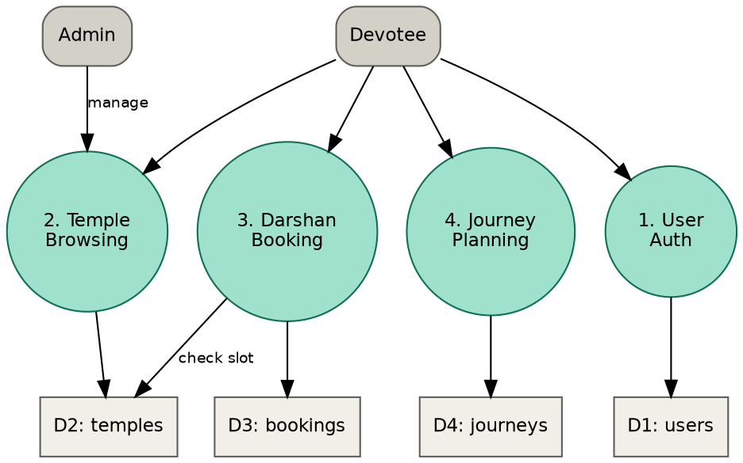
Figure 2: DFD Level 1 — sub-processes and data stores

Entity-Relationship Diagram
The ER diagram below shows how the User, Temple, Booking, Notification, and Journey Plan collections relate to one another. (The use case, activity, and sequence diagrams for this flow appear in the Solution Architecture document.)
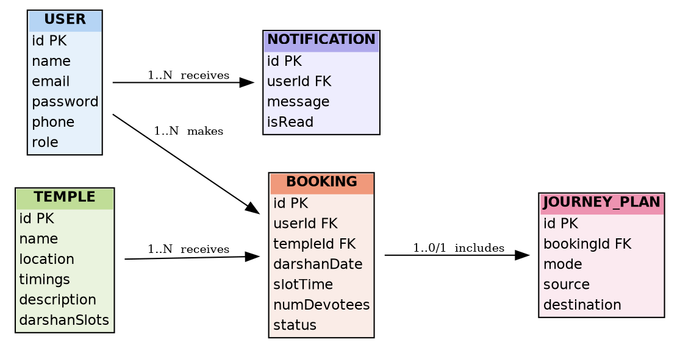
Figure 3: Entity-relationship diagram

User Stories
User Type | Functional Requirement (Epic) | User Story Number | User Story / Task | Acceptance Criteria | Priority | Release
Devotee | Registration | USN-1 | As a user, I can register by entering my name, email, phone, and password. | I can access my dashboard after successful registration. | High | Sprint-1
Devotee | Registration | USN-2 | As a user, I receive a confirmation once I have registered. | I can log in immediately after registering. | Medium | Sprint-1
Devotee | Login | USN-3 | As a user, I can log into the application using my email and password. | I am redirected to the dashboard on successful login. | High | Sprint-1
Devotee | Temple Listing | USN-4 | As a user, I can browse a list of temples with their locations. | I can see temple name, location, and timings. | High | Sprint-1
Devotee | Temple Details | USN-5 | As a user, I can view detailed information about a selected temple. | I can see darshan types, timings, and description. | High | Sprint-2
Devotee | Darshan Booking | USN-6 | As a user, I can select a date and slot to book darshan. | I can only select from available slots. | High | Sprint-2
Devotee | Booking Confirmation | USN-7 | As a user, I receive a confirmation with a booking ID after booking. | The booking appears in my booking history. | High | Sprint-2
Devotee | Booking History | USN-8 | As a user, I can view all my past and upcoming bookings. | Bookings are listed with status and date. | Medium | Sprint-3
Devotee | Journey Planner | USN-9 | As a user, I can search bus, train, and flight options for my trip. | Results show mode, timing, and estimated fare. | Medium | Sprint-3
Devotee | Notifications | USN-10 | As a user, I receive a notification when my booking is confirmed. | Notification is visible in-app or via email. | Low | Sprint-3
Admin | Admin Dashboard | USN-11 | As an admin, I can add and update temple and slot information. | Changes reflect immediately for all users. | High | Sprint-3
Admin | Admin Dashboard | USN-12 | As an admin, I can view and manage all devotee bookings. | I can filter bookings by temple and date. | High | Sprint-4

